**PIR Motion Sensor for Lamp**

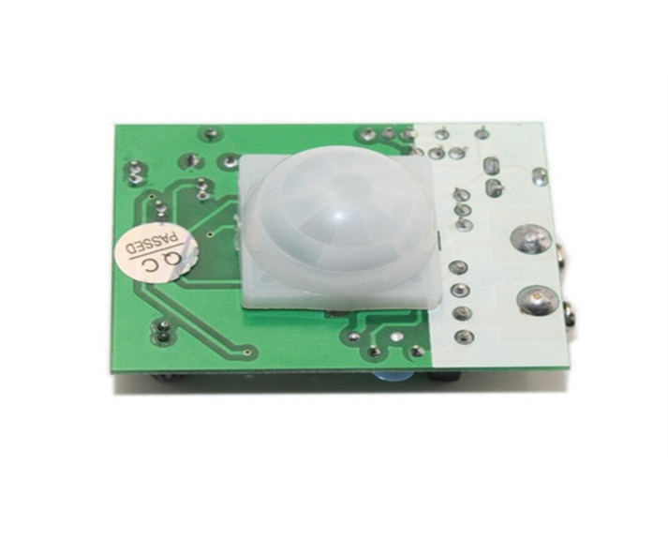

**Component use:**

is an electronic sensor that measures infrared (IR) light radiating from objects in its field of view.

**Component Diagram:**

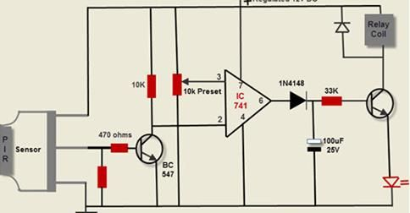

**component parameters:**

2- variables resistance (one for set distance, one for set delay) jumper for set mode for action

**component code:**

1. /*
2. * PIR sensor tester
3. */
4. int ledPin = 13; // choose the pin for the LED
5. int inputPin = 2; // choose the input pin (for PIR sensor)
6. int pirState = LOW; // we start, assuming no motion detected
7. int val = 0; // variable for reading the pin status
8. void setup() {
9. pinMode(ledPin, OUTPUT); // declare LED as output
10. pinMode(inputPin, INPUT); // declare sensor as input
11. Serial.begin(9600);
12. }
13. void loop(){
14. val = digitalRead(inputPin); // read input value
15. if (val == HIGH) { // check if the input is HIGH
16. digitalWrite(ledPin, HIGH); // turn LED ON
17. if (pirState == LOW) {
18. // we have just turned on
19. Serial.println("Motion detected!");
20. // We only want to print on the output change, not state
21. pirState = HIGH;
22. }
23. } else {
24. digitalWrite(ledPin, LOW); // turn LED OFF
25. if (pirState == HIGH){
26. // we have just turned of
27. Serial.println("Motion ended!");
28. // We only want to print on the output change, not state
29. pirState = LOW;
30. }
31. }
32. }

**:Guide Link**

<https://en.wikipedia.org/wiki/Passive_infrared_sensor#Product_design>

<https://learn.adafruit.com/pir-passive-infrared-proximity-motion-sensor/using-a-pir-w-arduino>

<https://store.fut-electronics.com/collections/object-detection/products/pir-motion-sensor-for-lamp>

<https://www.youtube.com/watch?v=NpfDeklt3W4>